R. Reports Menu: S. AP Vendor Distribution

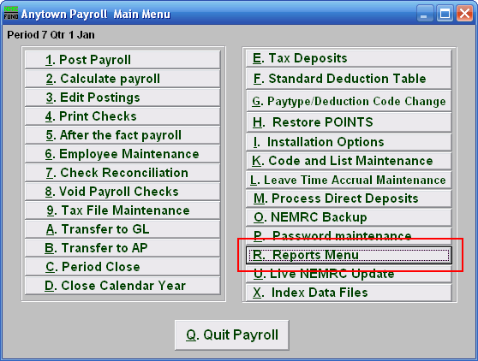
Click on “R. Reports Menu” from the Main Menu and the following window will appear:
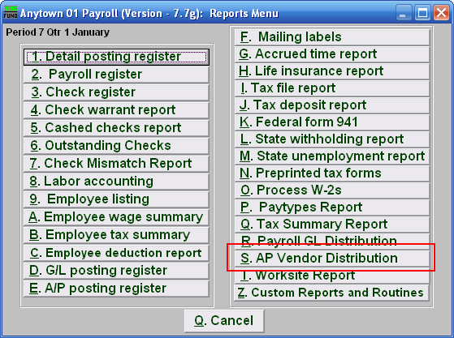
Click on “AP Vendor Distribution” from the Reports Menu and the following window will appear:
AP Vendor Distribution

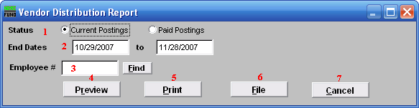
- Status: Select to report from either current unpaid postings or posting that have been paid.

- End Dates: Enter the beginning and ending pay periods to collect data for reporting.

- Employee #: Select the Employee # for the Employee you want this report to be for.

- Preview: Click this button to preview this report. Refer to GENERAL PREVIEW for more information.

- Print: Click this button to print this report. Refer to GENERAL PRINTING for more information.

- File: Click this button to save this report on this computer. Refer to GENERAL FILE for more information.

- Cancel: Click “Cancel” to cancel and return to the previous screen.

